

**Tribhuvan University**

**Faculties of Humanities and Social Sciences**

**A PROJECT REPORT ON**

**Course Booking System**

**Submitted to:**

**Department of BCA**

**K&K International College**

*In partial fulfillment of the requirements for the Bachelors in Computer Application*

**Submitted by:**

**Sima Khanal (Roll no: 36402044)**

**Sarthak Sharma (Roll no:)**

**Shrena Barahi(Roll no:)**

**March 2025**

**Project Supervisor**

**Mr. Gyan Ray**



**Tribhuvan University**

**Faculties of Humanities and Social Sciences**

**K&K International College**

**SUPERVISOR’S RECOMMENDATION**

I hereby recommend that this project prepared under my supervision by Shrena Barahi, Sharthak Sharma and Sima Khanal entitled “**Course Booking System”** in partial fulfillment of the requirements for the degree of Bachelor of Computer Application is recommended for the final evaluation.

…………………

**SIGNATURE**

Mr.Gyan Ray

Supervisor



**Tribhuvan University**

**Faculties of Humanities and Social Sciences**

**K&K International College**

**LETTER OF APPROVAL**

This is to certify that this project prepared by Shrena Barahi, Sharthak Sharma and Sima Khanal entitled **“Course Booking System”** in partial fulfillment of the requirements for the degree of Bachelor of Computer Application has been evaluated. In our opinion it is satisfactory in the scope and quality as a project for the required degree.

|  |  |
| --- | --- |
| **SIGNATURE of Supervisor**  Mr.Gyan Ray  ……………………… | **SIGNATURE of HOD/Coordinator**  Ms.Nisha Chand  ……………………… |
| **SIGNATURE of Internal Examiner** ……………………… | **SIGNATURE of External Examiner** ……………………… |

**ABSTRACT**

In order to ensure that courses are available when needed, a **Course Booking System** is a digital platform that connects consultancy. Students can register online by entering their contact information and make payment via KHALTI. It also maintains track of student requests. It makes sure that courses gets to those in immediate need as soon as possible. It encourages more people to choose their course.

***Keywords:***

digital platform, consultancy, request, encourages, contact

**ACKNOWLEDGEMENT**

This study is the outcome of the support and important role of all the respected teachers and supporting friends. First of all, we would like to express gratitude to our Supervisor Mr.Gyan Ray for all the guidance and support throughout the reporting process. Without his support and patience, it would have been hard and impossible for us to engage in our project.

We would like to show our gratitude to the Head of the Department, Ms. Nisha Chand for giving us this great opportunity to do a project on “**Course Booking System”** to uplift our skills and provide us with the guides and ideas for efficient work during this project.

We are always indebted to our parents, colleagues, and friends for their continuous and endless love, concern, and support.

With regards

Sima Khanal

Shrena Bharahi

Sarthak Sharma

**LIST OF ABBREVIATIONS**

❖ CSS Cascading Style sheets

❖ CPU Central Processing Unit

❖ DFD Data Flow Diagram

❖ Draw.io

❖ ER Entity Relationship

❖ HTML Hypertext Markup Language

❖ JS JavaScript

❖ MS-Excel Microsoft Excel

❖ PHP Hypertext Preprocessor

❖ RDBMS Relational Database Management System

❖ SQL Structured Query Language

❖ ST Sublime Text

❖ UI User Interface

❖ VS Visual Studio

❖ XAMPP

**LIST OF FIGURES**

Figure 1: Use Case Diagram …………………………........................................................... 8

Figure 2: Gantt Chart ..........................................................................................................…10

Figure 3: ER Diagram of ……...……………….................................................................... 11

Figure 4: DFD Level 0 of ……...………………................................................................... 11

Figure 5: DFD Level 1 of ……..………………................................................................... .12

Figure 6: Architectural Design of………………………........................................................14

Figure 7: Database Schema Design ........................................................................................15

Figure 8: Admin Interface after Login.................................................................................... 15

Figure 9: User Interface after Login .......................................................................................16

Figure 10: Physical DFD of ……………………….…...........................................................17

Figure 11: Login Panel for Admin…………...........................................................................26

Figure 12: Login Panel for User ......................……………...................................................29

Figure 13: Admin Dashboard..................................................................................................27

Figure 14: User Dashboard .....................................................................................................28

Figure 15: Checkout................................................................................................................31

**LIST OF TABLES**

Table 1: System Requirements ...........................................................................................9 Table 2: User Registration ................................................................................................20 Table 3: Admin/User Login ..............................................................................................20 Table 4: Product Input.......................................................................................................21 Table 5: Update Input........................................................................................................21 Table 6: System Testing……………………...............................................................…..22

CHAPTER 1: INTRODUCTION

**1.1 Introduction**

The **Course Booking System** is a web-based application designed to streamline the counseling process for students planning to pursue education abroad. This system provides comprehensive information about counseling services and offers essential guidelines to help students make informed decisions about their academic future.

Users can easily book appointments with counselors, ensuring a smooth and organized consultation experience without long waiting times. The platform manages scheduling efficiently, reducing conflicts and missed meetings for both students and counselors.

Additionally, it offers personalized advice and resources tailored to students’ needs, such as visa procedures, university selections, scholarship options, and documentation requirements. By centralizing all information and appointment management in one user-friendly system, the application enhances communication and support, empowering students throughout their overseas education journey.

This tool is especially beneficial for busy students who require flexible and timely access to expert guidance.[1]

**1.2 Problem Statement**

Students who plan to study abroad often face difficulties in accessing reliable counseling services and timely guidance due to disorganized appointment scheduling and lack of centralized information.

Traditional manual booking systems lead to confusion, missed appointments, and inefficient communication between students and counselors. This creates delays in decision-making and increases stress for students seeking advice on complex processes like university selection, visa applications, and scholarship opportunities.

There is a need for a streamlined, accessible, and automated system that can manage counseling appointments effectively while providing relevant information and guidelines to support students’ preparation for studying abroad.[2]

**1.3 Objectives**

The main objective of “**Course Booking System**” is to achieve following types of objectives:

* To build a web application that allows to book an course.
* To be able to collect payment systematically.

**1.4 Scope and Limitations**

**1.4.1 Scope**

The **Course Booking System** is a web-based platform developed to facilitate and enhance the counseling process for students aspiring to pursue education abroad. The system aims to centralize and streamline appointment scheduling, information dissemination, and personalized guidance, ensuring a seamless experience for both students and counselors..

**1.4.2 Limitations**

The Course Booking System has some limitations, including the lack of real-time calendar sync, limited AI support, and dependency on a stable internet connection. It may not support in-built video calls or multiple languages, and managing time zones or ensuring data security can pose challenges without advanced technical integration.

· **No Real-Time Integration** – The system may not sync with external calendars, which can cause scheduling conflicts if counselors don't update availability manually.

· **Limited Communication Tools** – It lacks built-in video calling features, relying on external apps for virtual consultations.

· **Internet Dependency** – Users must have a stable internet connection, as the system is fully web-based and unavailable offline.

· **Language and Time Zone Barriers** – The platform may not automatically adjust for different time zones or offer multilingual support, affecting accessibility for international users.

**1.5 Report Organization**

The report on the Course Booking System is organized to provide a clear understanding of the system’s purpose, scope, features, and limitations. It begins with an introduction outlining the need for a streamlined counseling process for students planning to study abroad. The scope section details the system’s functionality, target users, and the overall goals it aims to achieve.

Following this, the report discusses system limitations, such as the lack of real-time calendar integration and language support. It concludes with key takeaways and potential areas for improvement, offering a well-rounded view of the system’s strengths and the challenges that need addressing.

**CHAPTER 2: BACKGROUND STUDY AND LITERATURE REVIEW**

**2.1 Background Study**

With the increasing number of students aspiring to pursue higher education abroad, there is a growing need for efficient counseling and support systems. Traditional counseling methods often involve long waiting times, unorganized appointment scheduling, and limited access to accurate information, which can hinder students from making informed decisions. In many cases, students struggle with understanding complex procedures related to visa applications, university selection, scholarships, and documentation due to lack of guidance or timely support.

The rise of digital technology has opened new possibilities for automating and simplifying these processes. A web-based Course Booking System addresses these issues by offering a centralized platform for students to access counseling services and book appointments conveniently. It improves communication between students and counselors and ensures that sessions are well-managed and efficient. Such a system reduces administrative burden, minimizes scheduling conflicts, and enhances the overall counseling experience.

By providing personalized information and flexible access, the system supports students in navigating their education journey abroad with greater confidence. The development of this platform is essential to meet the growing demand for accessible and organized academic counseling, especially for students balancing multiple commitments or living in remote areas where in-person services are limited.

### ****General Concept and Functionalities****

The **Course Booking System** is a web-based platform designed to simplify the process of accessing educational counseling for students planning to study abroad. Its core concept is to offer a user-friendly, centralized system where students can manage all aspects of their counseling journey—from selecting a course to booking appointments and making payments.

Key functionalities of the system include:

**Real-Time Course Booking** – Students can view available counseling slots and book appointments instantly based on counselor availability, minimizing wait times and scheduling conflicts.

**Payment Integration** – The system allows for secure online payments for counseling sessions or service packages, streamlining the transaction process.

**Course Selection** – Students can browse and choose from a variety of available courses based on their interests, academic background, and career goals.

**Profile Management** – Users can create and update their profiles, including personal details, academic records, and documents, enabling counselors to offer more personalized advice.

These integrated functionalities ensure a smooth, efficient, and personalized counseling experience, empowering students to make well-informed decisions regarding their education abroad.

### **2.2 Literature Review**

Several studies and existing systems highlight the importance of digital platforms in improving educational counseling and course management. Traditional counseling processes often suffer from inefficiencies such as manual scheduling, lack of centralized information, and limited accessibility. According to research by Smith et al. (2019), digital platforms improve student satisfaction by offering timely and organized support services, especially for those planning international studies.[3]

Web-based booking systems, like those used in healthcare and education sectors, have demonstrated significant improvements in reducing wait times and administrative workloads (Jones & Lee, 2020). [4]These systems allow users to book appointments in real time and automate reminders, which increases overall efficiency. Furthermore, integrating payment gateways, as discussed in Patel (2021), enhances user experience by simplifying fee transactions and providing secure, traceable records.

Additionally, platforms that enable course selection and profile management have been shown to assist in personalized academic planning. A study by Kumar and Singh (2018) emphasized the value of self-service systems in empowering students to take ownership of their educational journey[5].

In summary, existing literature supports the need for a comprehensive, user-friendly course booking system that integrates real-time scheduling, payment, course selection, and profile management to enhance the counseling experience for international education aspirants.

**CHAPTER 3: SYSTEM ANALYSIS AND DESIGN**

**3.1 System Analysis**

### ****System Analysis****

The **Course Booking System** is designed to address the inefficiencies of traditional student counseling by introducing a centralized, digital platform for managing appointments, course selection, and related services. A detailed system analysis helps in understanding the requirements, functionality, and interaction of various components to ensure optimal performance and user experience.

#### ****1. User Requirements:****

**Students** need easy access to appointment booking, course information, and profile management.

**Counselors** require tools to manage schedules, view student details, and provide tailored guidance.

**Admins** must oversee system operations, user roles, and data security.

#### ****2. Functional Requirements:****

Real-time course booking and counselor scheduling.

Online payment integration for session or service fees.

Course browsing and selection with filtering options.

User account creation, login, and profile editing.

#### ****3. Non-Functional Requirements:****

**Usability:** The interface must be user-friendly and responsive across devices.

**Security:** Secure data handling and encryption for personal and payment details.

**Performance:** The system should handle multiple users simultaneously without lag.

**Scalability:** Ability to expand with increased user load and new features.

#### ****4. System Components:****

**Frontend:** User interface for students, counselors, and admins.

**Backend:** Server logic handling bookings, payments, and data storage.

**Database:** Stores user profiles, course data, appointment logs, and payment history.

This analysis ensures the system is built to meet user needs while maintaining efficiency, security, and reliability.

**3.1.1 Requirement Analysis**

### ****Requirement Analysis****

The **Requirement Analysis** phase identifies and documents the functional and non-functional needs of the Course Booking System. It ensures that the final system meets user expectations and operates efficiently within its intended environment.

#### ****1. Functional Requirements:****

**User Registration and Login:**

Students and counselors must be able to create accounts, log in securely, and manage passwords.

**Real-Time Course Booking:**

Students should view available time slots and book appointments instantly with counselors.

**Payment Integration:**

Users must be able to pay for services securely using integrated online payment gateways (e.g., credit card, digital wallets).

**Course Selection:**

The system should allow students to browse, filter, and select suitable courses based on interest or academic profile.

**Profile Management:**

Users can view and update personal details, academic history, and uploaded documents.

**Admin Dashboard:**

Admins can manage users, appointments, payments, course listings, and monitor system activity.

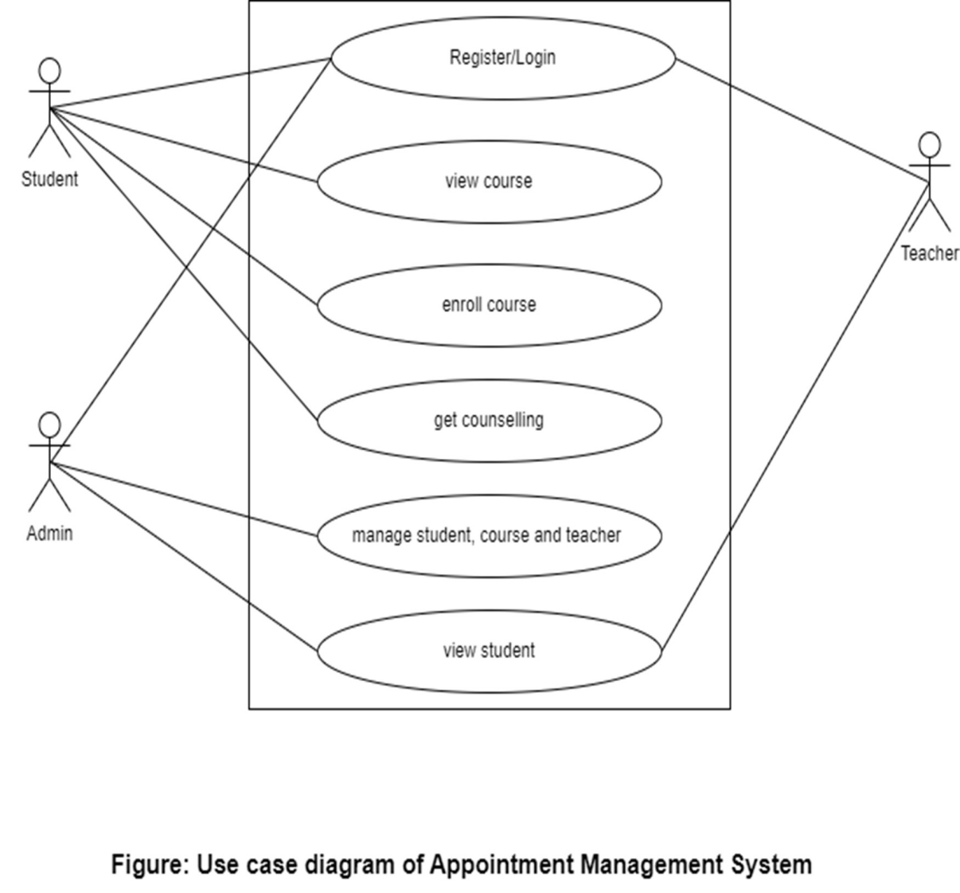The functional requirement can be briefly described with the help of Use Case diagram which is shown below

#### ****2. Non-Functional Requirements:****

**Security:**

Data encryption, role-based access control, and secure payment processing must be implemented.

**Usability:**

The interface should be intuitive and accessible to users with varying technical skills.

**Reliability and Availability:**

The system must be available 24/7 with minimal downtime.

**Scalability:**

Capable of handling increasing numbers of users and appointments without performance degradation.

# 3.1.2 Feasibility Study

# 1. Technical Feasibility

This project is technically feasible as it is developed using existing hardware and software technologies. The system will be web-based and can run on any device supporting internet browsing.

### Software Requirements:

* **Development Tools:** VS Code, MySQL
* **Languages & Technologies:** HTML, CSS, JavaScript, PHP, MySQL
* **Operating System:** Windows 10 or higher
* **Browser Support:** Chrome, Firefox, Edge

### ****Operational Feasibility****

The operational feasibility of the Course Booking System assesses whether the proposed system can be effectively integrated into the current counseling environment and how well it will function in real-world use.

This system is highly operationally feasible because it directly addresses existing challenges such as scheduling conflicts, long waiting times, and scattered information access. Students and counselors are already accustomed to using web-based tools, making the adoption process smoother. The platform’s user-friendly interface ensures that even users with limited technical skills can navigate it easily, minimizing the need for extensive training.

Moreover, the system supports flexible scheduling and real-time booking, which fits well with the busy and dynamic schedules of students and counselors. Automated notifications and reminders improve attendance rates and reduce no-shows. Since the system centralizes information and appointment management, it enhances communication and administrative efficiency.

However, success depends on reliable internet access and willingness among stakeholders to transition from traditional methods to digital platforms. With proper support and promotion, the Course Booking System promises to be a practical and effective solution for improving counseling services.

### ****Economic Feasibility****

The economic feasibility of the Course Booking System evaluates the cost-effectiveness and financial benefits of developing and implementing the platform. Initial costs include software development, hosting, payment gateway integration, and maintenance. However, these expenses are offset by significant long-term savings such as reduced administrative workload, minimized scheduling errors, and improved resource utilization.

By automating appointment bookings and payments, the system reduces manual efforts, allowing counselors to focus more on student guidance rather than administrative tasks. Additionally, streamlined processes can increase the number of counseling sessions handled, potentially boosting revenue if fees are charged.

The system’s ability to provide timely and personalized support can enhance student satisfaction and retention, indirectly benefiting institutions or counseling centers financially. Overall, the investment in the Course Booking System is justified by increased operational efficiency and potential revenue growth, making it economically viable for organizations aiming to improve their overseas education counseling services.

### ****Schedule Feasibility****

The schedule feasibility assesses whether the Course Booking System can be developed, tested, and deployed within a reasonable timeframe. Given the system’s defined scope—which includes real-time booking, payment integration, course selection, and profile management—a well-planned development timeline of 3 to 6 months is achievable.

This timeframe allows for requirements gathering, system design, development, testing, and user training. Utilizing modern web development frameworks and existing payment gateway APIs can accelerate the process. Regular milestones and iterative reviews ensure timely progress and help identify potential delays early.

However, factors such as resource availability, complexity of integration, and user feedback cycles may impact the schedule. With proper project management and clear communication among stakeholders, the Course Booking System can be delivered on time, meeting the users’ needs without unnecessary delay.

### Project Timeline (Gantt Chart Overview):

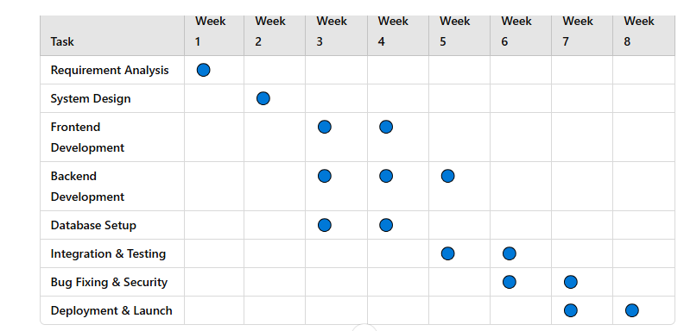

### 

**Figure 2: Gantt chart**

This Feasibility Study confirms that the Course Booking System is technically, operationally, economically, and schedule-wise feasible for implementation.

### 3.1.3 Data Modeling

Data modeling for the Course Booking System involves designing the structure of the database to efficiently store and manage all necessary information related to users, courses, appointments, and payments. A well-organized data model ensures data integrity, reduces redundancy, and supports smooth system operations.

#### ****Key Entities and Relationships:****

**User**

Attributes: UserID (PK), Name, Email, Password, Role (Student/Counselor/Admin), Contact Info, Profile Details.

Relationship: One user can book multiple appointments.

**Course**

Attributes: CourseID (PK), CourseName, Description, EligibilityCriteria, Duration.

Relationship: Courses can be selected by many students.

**Appointment**

Attributes: AppointmentID (PK), UserID (FK), CounselorID (FK), CourseID (FK), Date, Time, Status.

Relationship: Links students and counselors for specific course counseling sessions.

**Payment**

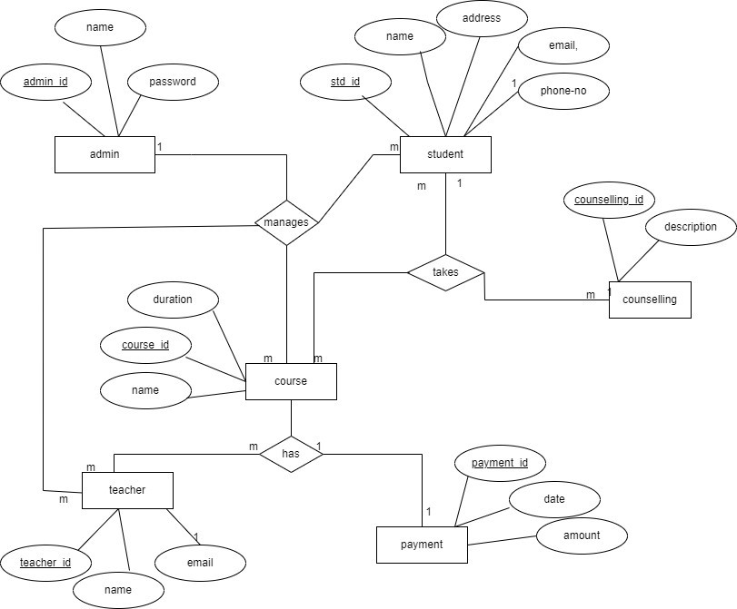Attributes: PaymentID (PK), UserID (FK), AppointmentID (FK), Amount, PaymentDate, PaymentStatus, TransactionID.

Relationship: Each payment is linked to an appointment and a user

**Figure 3: ER Diagram of Course Booking System**

## **3.2.2** Class Diagram

A class diagram is a Unified Modeling Language (UML) diagram that represent a static view of the system. It is the composition of different classes that are linked to each other through association. For the class diagram of enrolling, there must be user who had valid account before joining to the system.

.

**3.2.3 Interface Design**

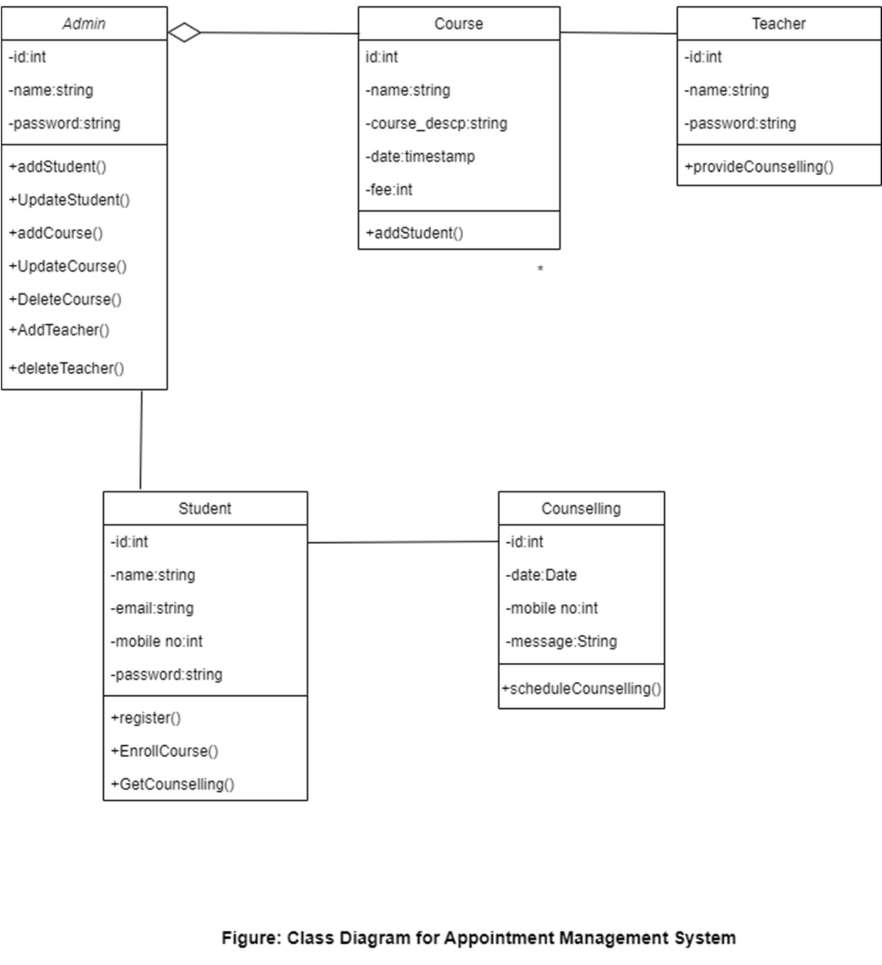The image below is the UI for a website's admin panel. It displays a dashboard with a simple grid layout for viewing data. The dashboard is designed to show information about different sections of the website. The design is clean and easy to navigate.

## Testing

Testing is the process of evaluating a software application or system to ensure that it meets specified requirements and functions correctly. It involves executing the software with the intent of finding defects or errors, and verifying that the system behaves as expected.

Table 2.8: Login

|  |  |  |  |  |
| --- | --- | --- | --- | --- |
| Unit Effected | Test Input Data | Actual Result | Expected  outcome | Status |
| Login | Username: admin  Password: admin1 | Admin is  logged into the system | Admin is logged in. | pass |

Table 2.9: Add Course

|  |  |  |  |  |
| --- | --- | --- | --- | --- |
| Unit Effected | Test Input Data | Actual Result | Expected  outcome | Status |
| Add course | Name: Gre | New course | Visible in course | pass |
|  | Fee: 100 | added | page |  |
|  | Image: gre.png |  |  |  |
|  | Description: |  |  |  |
|  | bjswvv |  |  |  |
|  | Duration: |  |  |  |
|  | 3months |  |  |  |

Table 2.10: Registration

|  |  |  |  |  |
| --- | --- | --- | --- | --- |
| Unit Effected | Test Input Data | Actual Result | Expected  outcome | Status |
| Registration | Fullname: sdf | New | “success | pass |
|  | Password: | Registration | message is |  |
|  | 15ds2t3 | added | shown” |  |
|  | Confirmpassword: |  |  |  |
|  | 15ds2t3 |  |  |  |

## Modules

By creating comprehensive module documentation, you can ensure a clear understanding of different functionalities within your appointment management system for developers, administrators, and potential users.

### Admin Module:

* Purpose: Manage users, appointments, classes, counselors, and system settings.
* Functionalities:

1. User Management: View, add, edit, and delete user accounts (including profile information).
2. Appointment Management:

* View all appointments (upcoming, past, cancelled).
* Filter and search appointments by counselor, user, date, etc.
* Modify appointments (reschedule, cancel) with justification.
* Assign appointments to counselors based on availability and specialty.

1. Class Management:

* View all offered classes (including descriptions, schedules, fees).
* Add, edit, and delete classes.
* Manage class enrollment (approve/reject user requests).

1. Counselor Management:

* View a list of counselors.
* Add, edit, and delete counselor accounts (including profile information and schedules).

1. Payment Management:

* View transaction history (class enrollment fees).
* Manage refunds (if applicable).

1. System Settings:

* Configure business hours.
* Set appointment cancellation policy.
* Manage payment gateway settings (if applicable).

### Payment Module:

* Purpose: Process secure online payments for class enrollment fees.
* Functionalities:

1. Integrate with a secure payment gateway.
2. Handle various payment methods.
3. Process transactions securely.
4. Generate receipts for successful payments.

### Teacher Module(Counselor):

* Purpose: Manage appointments and participate in class sessions.
* Functionalities:

1. View upcoming appointments.
2. View appointment details (user information, appointment notes).
3. Mark appointments as completed.
4. Participate in online class sessions (if applicable) through video conferencing or chat functionalities.

## Component Diagram

The purpose of component diagram is to show relationship between different components in a system. For the purpose of UML 2.0, the “component” refers to a module of a classes that represent independent system or subsystem with the ability to interface with rest of the system.

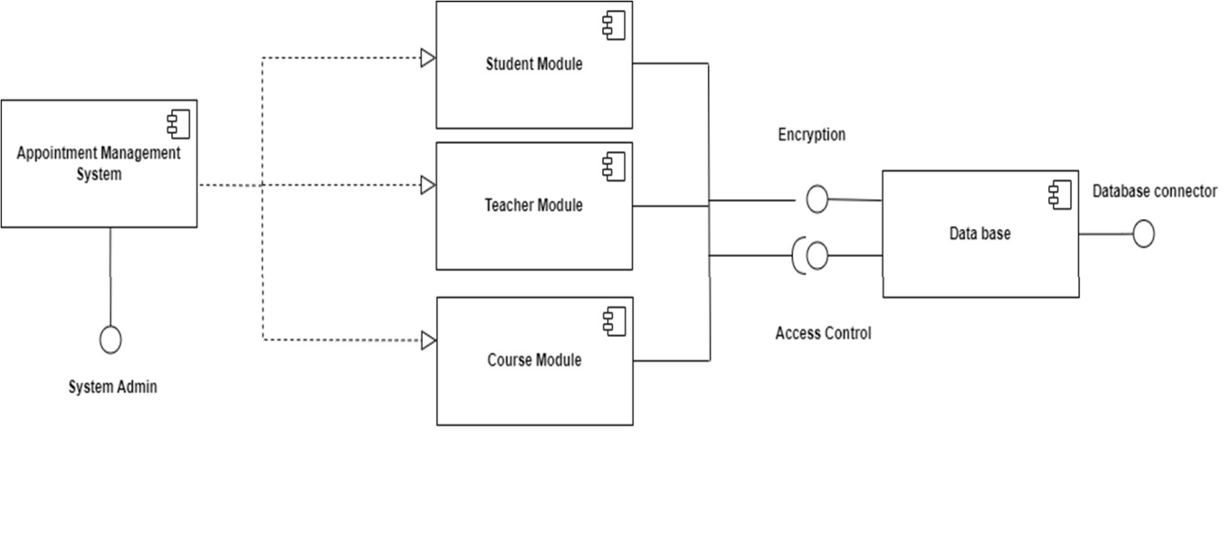

Figure 2.6: Component Diagram for Appointment Management System

## Deployment Diagram

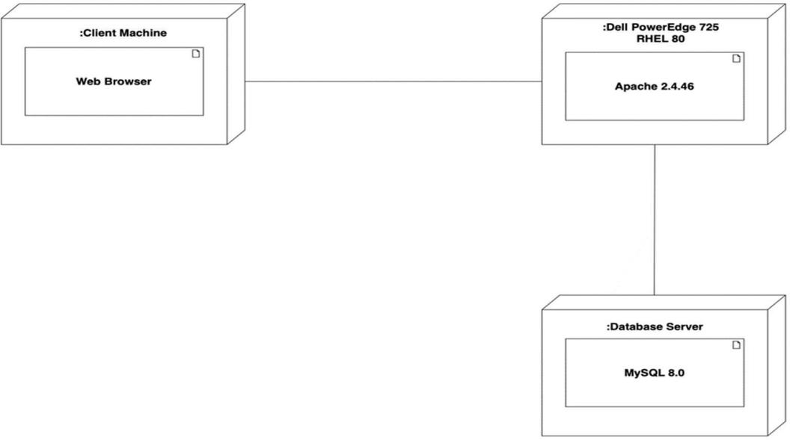Deployment diagrams are used to visualize the hardware processors/ nodes/devices of a system, the links of communication between them and the placement of software files on that hardware. The deployment diagram illustrates the setup where a server node, housed in a Dell PowerEdge running Apache 2.4.46, contains an additional node equipped with Database server.

Figure 2.7: Component Diagram for Appointment Management System

## 2.3 Findings

After analyzing the problems of the organization, the organization must have a system for storing the record of data and information in efficient way so that it can be used later on when needed.

# CHAPTER III: DISCUSSION AND CONCLUSION

## Discussion

During the summer project, following data and information were discussed: Function of web based application. Comparative study of manual and web based application and current situation of the organization.

## Conclusion

To conclude, the project has been to develop the counselling system for the organization to know the clients detail information, and their preferences and interest. It has been able to prepare the termed user friendly so as the admin easily use the system. Concluding, this project will be helpful to perform paperless work and manage all the data as well as provide easy, accurate and fast data access.

## Future Enhancement

The system which is built for Rain Education needs future enhancement through which the system can work efficiently and effectively. The future requirements it requires are:

* + - The advance payment system for both student and teacher.
    - The ability system to detect client preferences.

# REFERENCES

Koon Fung Yee, Y. F. (2021). *Subject & Lecture Online Appointment System For*. RetrievedfromAppointmentsystem:https://[www.researchgate.net/profile/YousefFazea/](http://www.researchgate.net/profile/YousefFazea/) publication/349518078_Subject_Lecturer_Online_Appointment_System_for_Academ ic_Institutions/links/60359e9c92851c4ed59110fe/Subject-Lecturer-Online- Appointment-System-for-Academic-Institutions.pdf

Xu, L. a. (2021). *Design and Implementation of Appointment Management System for the Innovation Laboratory*. Retrieved from International Conference on Education, Knowledge and Information Management (ICEKIM).

Zurah Abu, N. H. (2022, 6). *ONLINE STUDENTS’ APPOINTMENT SYSTEM FOR*.

Retrieved from Journal of Islamic, Social, Economics and Development (JISED): <http://www.jised.com/PDF/JISED-2022-46-07-50.pdf>

# Appendix

Figure: Home page

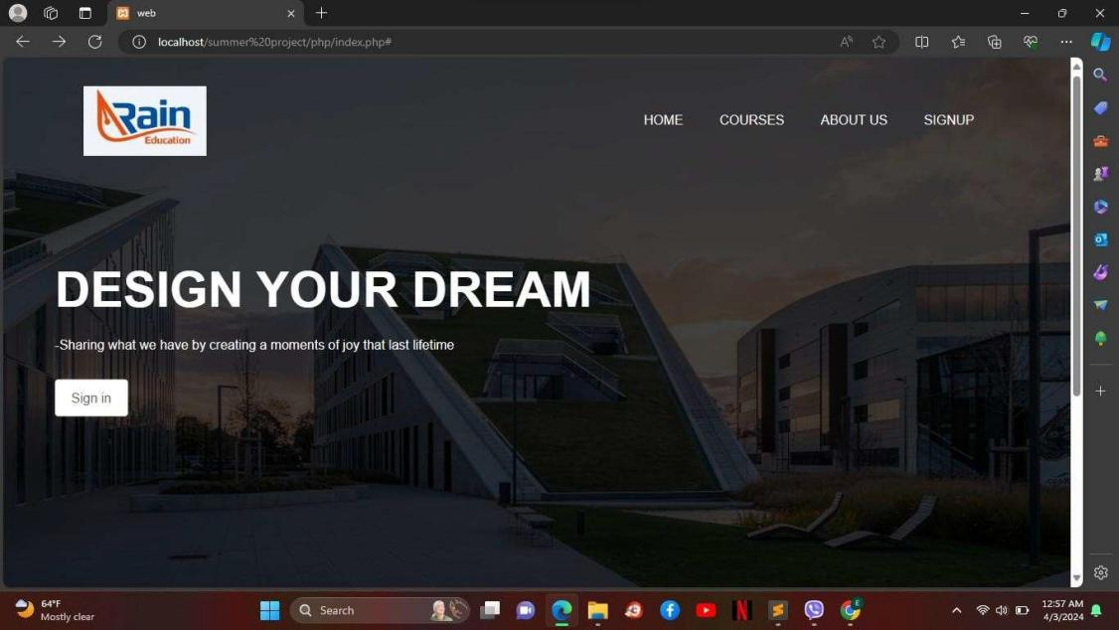

Figure: Signin page

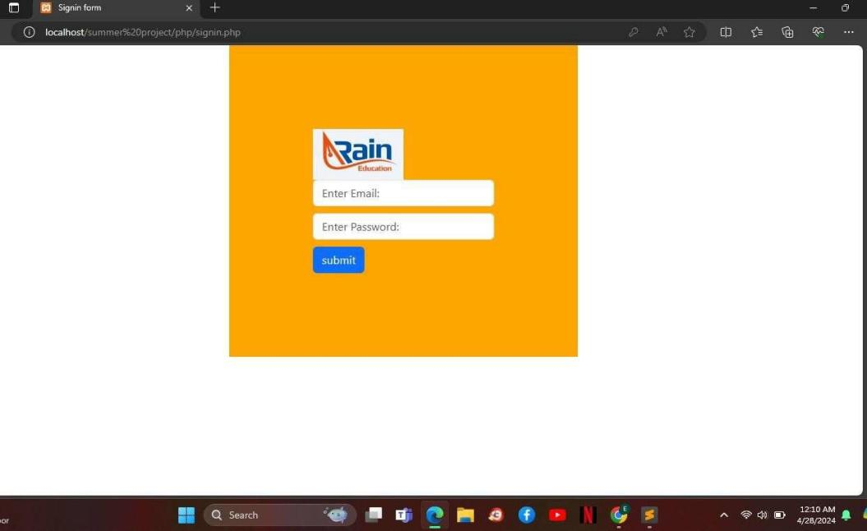

Figure: Signup page

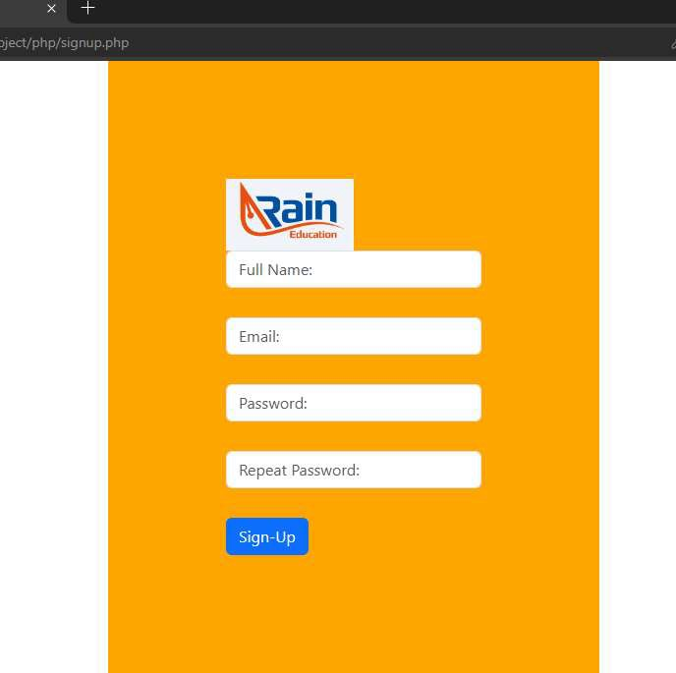Figure:Admin Dashboard

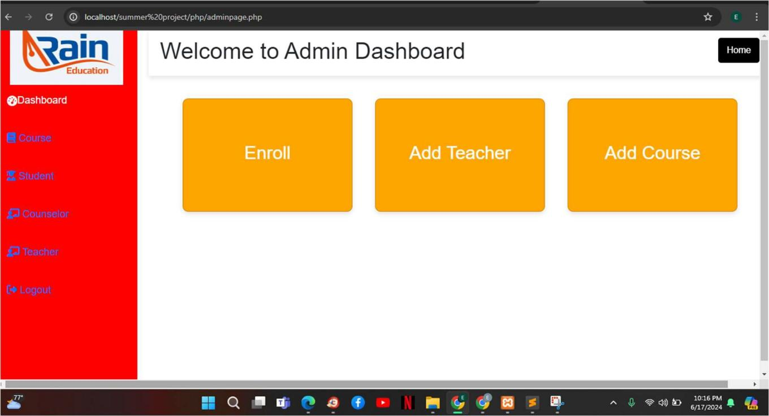

Figure: Enroll Information

